SIR SYED UNIVERSITY OF ENGINEERING & TECHNOLOGY
COMPUTER SCIENCE & INFORMATION TECHNOLOGY DEPARTMENT

Fall 2024
Probability & Statistics (MS-301T)
Assignment # 1

Semester: 5TH Batch: 2022
Announced Date: Due Date: :
Total Marks:03 Marks Obtained:

CLO # | Course Learning Outcomes (CLOs) | PLO Mapping | Bloom’s Taxonomy
CLO 1 | Describe the theoretical concept of descriptive statistics, inferential & probability | PLO_1  (Academic Education) | C2  (Understanding)

Q1 Arrange that the Environmental Protection Agency of a developed country performs extensive tests on all new car models in order to determine their mileage rating. Suppose that the following 30 measurements are obtained by conducting such tests on a particular new car model.

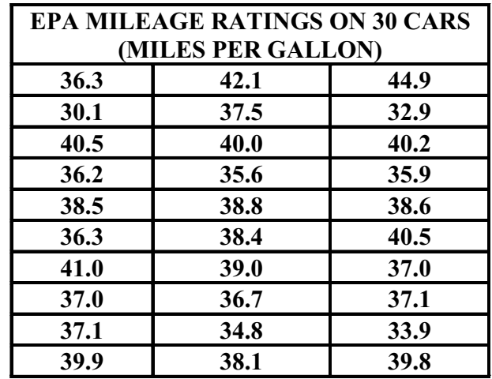

- Describe Construction of a Frequency Distribution
- What is the significance of quantitative research?

Q2 Tell the data as either qualitative or quantitative; if quantitative, further classify it as discrete or continuous. Also, identify the variable under consideration in each case.
2.1 The highest temperatures on record for selected cities are collected by the U.S. National Oceanic and Atmospheric Administration and published in Comparative Climatic Data. The following table displays data for years through 2007
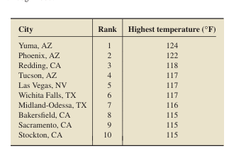

a. What type of data is presented in the second column of the table?
b. What type of data is provided in the third column of the table?
c. What type of data is provided by the information that Phoenix is in Arizona?

2.2) Top Wi-Fi Countries. According to JiWire, Inc., the top 10 countries by number of Wi-Fi locations, as of October 27, 2008, are as shown in the following table.
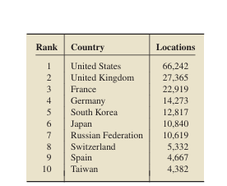

Identify the type of data provided by the information in each of the following columns of the table: a. first b. second c. third

